Ref: WP3-FSD | Issue Date: 23/06/05 | Version Number: 1.2
Contract REPORTNET 02020400/2004/394786/MAR/G3

Functional specificationS DOCUMENT
for
WeB DASHBOARDS service

Written by:  EUROPEAN DYNAMICS S.A.  Mr. Nedeljko Pavlovic | Sign Off and Date:  23/06/05 |  | Appraisal Authority:  EEA  Mr. Stefan Jensen | Sign Off and Date:
Verified by:  EUROPEAN DYNAMICS S.A.  Dr. Zack Protogeros | Sign Off and Date:  23/06/05 |  | Appraisal Authority:  EEA | Sign Off and Date:
Approved by:  EUROPEAN DYNAMICS S.A.  PROJECT MANAGER  Dr. Stelios Papastratos | Sign Off and Date:  23/06/05 |  |  | Sign Off and Date:

Table of Contents
Table of Contents ii
Table of Figures iv
Circulation List iv
Document History v
1 Introduction 6
1.1 Purpose 6
1.2 Document Conventions 6
Acronyms/Abbreviations: 6
Terminology: 6
Definitions: 7
1.3 Overview 7
1.4 Project Scope 7
1.5 References 7
2 Overall Description 8
2.1 Product Perspective 8
2.1.1 Operating environment 9
2.2 Product Features 10
2.2.1 Administrative features 10
2.2.2 REPORTNET Users features 13
2.2.3 Common features 13
2.2.4 External system features 14
2.3 User Classes and Characteristics 15
2.3.1 EIONET Administrator 16
2.3.2 REPORTNET user 16
2.3.3 User 16
2.4 User Documentation 16
3 Specific requirements 17
3.1 External Interface Requirements 17
3.1.1 User Interfaces 17
3.1.2 Hardware Interfaces 17
3.1.3 Software Interfaces 17
3.1.4 Communications Interfaces 18
3.2 Functional requirements 18
3.2.1 EIONET Administrator 19
3.2.1.1 Manage the channel server 19
3.2.1.1.1 Introduction/Purpose 19
3.2.1.1.2 Stimulus/Response sequence 19
3.2.1.1.3 Associated Functional requirements 19
3.2.1.2 Add content channel 20
3.2.1.2.1 Introduction/Purpose 20
3.2.1.2.2 Stimulus/Response sequence 20
3.2.1.2.3 Associated Functional requirements 20
3.2.1.3 Edit content channel 21
3.2.1.3.1 Introduction/Purpose 21
3.2.1.3.2 Stimulus/Response sequence 21
3.2.1.3.3 Associated Functional requirements 21
3.2.1.4 Delete content channel 22
3.2.1.4.1 Introduction/Purpose 22
3.2.1.4.2 Stimulus/Response sequence 22
3.2.1.4.3 Associated Functional requirements 23
3.2.1.5 Manage Access permissions 23
3.2.1.5.1 Introduction/Purpose 23
3.2.1.5.2 Stimulus/Response sequence 23
3.2.1.5.3 Associated Functional requirements 23
3.2.1.6 Manage dashboard profiles 24
3.2.1.6.1 3.2.1.6.1 Introduction/Purpose 24
3.2.1.6.2 Stimulus/Response sequence 24
3.2.1.6.3 Associated Functional requirements 24
3.2.1.7 Create dashboard profile 25
3.2.1.7.1 Introduction/Purpose 25
3.2.1.7.2 Stimulus/Response sequence 25
3.2.1.7.3 Associated Functional requirements 25
3.2.1.8 Edit dashboard profile 26
3.2.1.8.1 Introduction/Purpose 26
3.2.1.8.2 Stimulus/Response sequence 26
3.2.1.8.3 Associated Functional requirements 26
3.2.1.9 Delete dashboard profile 27
3.2.1.9.1 Introduction/Purpose 27
3.2.1.9.2 Stimulus/Response sequence 27
3.2.1.9.3 Associated Functional requirements 27
3.2.1.10 Manage UI templates 28
3.2.1.10.1 Introduction/Purpose 28
3.2.1.10.2 Stimulus/Response sequence 28
3.2.1.10.3 Associated Functional requirements 28
3.2.1.11 Edit page header 29
3.2.1.11.1 Introduction/Purpose 29
3.2.1.11.2 Stimulus/Response sequence 29
3.2.1.11.3 Associated Functional requirements 29
3.2.1.12 Edit page footer 30
3.2.1.12.1 Introduction/Purpose 30
3.2.1.12.2 Stimulus/Response sequence 30
3.2.1.12.3 Associated Functional requirements 30
3.2.2 REPORTNET user 37
3.2.2.1 Select dashboard profile 37
3.2.2.1.1 Introduction/Purpose 37
3.2.2.1.2 Stimulus/Response sequence 37
3.2.2.1.3 Associated Functional requirements 37
3.2.2.2 View dashboard 37
3.2.2.2.1 Introduction/Purpose 37
3.2.2.2.2 Stimulus/Response sequence 37
3.2.2.2.3 Associated Functional requirements 38
3.2.2.3 Customize layout 39
3.2.2.3.1 Introduction/Purpose 39
3.2.2.3.2 Stimulus/Response sequence 39
3.2.2.3.3 Associated Functional requirements 39
3.2.2.4 Download standalone dashboard 39
3.2.2.4.1 Introduction/Purpose 39
3.2.2.4.2 Stimulus/Response sequence 39
3.2.2.4.3 Associated Functional requirements 39
3.2.3 Common features 40
3.2.3.1 Login 40
3.2.3.1.1 Introduction/Purpose 40
3.2.3.1.2 Stimulus/Response sequence 40
3.2.3.1.3 Associated Functional requirements 40
3.2.4 External system features 41
3.2.4.1 Provide channel content 41
3.2.4.1.1 Introduction/Purpose 41
3.2.4.1.2 Stimulus/Response sequence 41
3.2.4.1.3 Associated Functional requirements 41
3.2.4.2 Get channel content 41
3.2.4.2.1 Introduction/Purpose 41
3.2.4.2.2 Stimulus/Response sequence 41
3.2.4.2.3 Associated Functional requirements 41
3.3 Nonfunctional requirements 46
3.3.1 Software Quality Attributes 46
3.3.2 Functionality 47
3.3.2.1 Reliability 48
3.3.2.2 Usability 49
3.3.2.3 Efficiency 50
3.3.2.4 Maintainability 50
3.3.2.5 Portability 51
3.3.3 Design and implementation constraints 51
4 Appendix A: Example dashboard 53
5 Appendix B: Requirements Traceability Matrix 54

Table of Figures
Figure 1 - Web Dashboards Service block diagram 9
Figure 2 - Administrative features Use Case diagram 13
Figure 3 - REPORTNET User features Use Case diagram 13
Figure 4 - Common features Use Case diagram 14
Figure 5 - External system features Use Case diagram 15
Figure 6 - User classes’ hierarchy Use case diagram 15
Figure 7 – Software quality attributes diagram 47
Figure 8 – Example dashboard layout 53

Circulation List

Name | Company/Institution
Mr. Nedeljko Pavlovic | EUROPEAN DYNAMICS S.A.
Dr. Zack Protogeros | EUROPEAN DYNAMICS S.A.
Dr. Stelios Papastratos | EUROPEAN DYNAMICS S.A.
Mr. Stefan Jensen | EEA
Mr. Soren Roug | EEA

Document History

Ver. | Date |  | Confidentiality | Description | Action | Pages
1.0 | 17-03-05 | Normal |  | WP3-FSD | C | 46
1.1 | 01-04-05 | Normal |  | WP3-FSD updated to include EEA comments | R | 47
1.2 | 23-06-05 | Normal |  | Inlcude EEA comments | I/R | 58
(*) Action: I = Insert; R = Replace; C = Creation

Introduction

Purpose
This document presents the software requirements specifications for the REPORTNET Web Dashboards service (WDS). Its aim is to provide a clear understanding between European Environment Agency and European Dynamics on the software requirements. Moreover, it will allow Software architects and Test designers to design the system and prepare the appropriate test design documentation.

Document Conventions

Acronyms/Abbreviations:

EEA - European Environment Agency
WDS - Web Dashboards Service
FSD - Functional Specifications Document
EIONET - The European environmental information and observation network
REQ - Each requirement is uniquely identified by REQ and appropriate sequence number
XML - Extensible Markup Language
RDF - Resource Description Framework
RSS - Really Simple Syndication
HTTP - Hypertext Transfer Protocol
XML-RPC. - Remote procedure calling using HTTP as the transport protocol and XML as the encoding protocol.
UI - User interface
<TBD> - Tag used for signing requirements that needs more detailed explanations from the side of the EEA

Terminology:

THE SYSTEM SHALL - A required, must-have feature
THE SYSTEM SHOULD - A desired feature, but may be deferred till later
THE SYSTEM MAY - An optional, nice-to-have feature that may never make it to implementation.

Definitions:
Priority - Attribute used to describe the importance of the requirement. Priority may have a value of HIGH, MEDIUM or LOW which corresponds to the previously introduced terms (SHALL, SHOULD, or MAY).
WDS Channel - The WDS entity that describes one external web resource used to get one type of data.

Overview
In this functional requirements specifications document, section 1 identifies the scope of the system, the purpose of the software, and lists the definitions, acronyms, abbreviations, and reference documents.
Section 2 provides the general factors that affect the product and its requirements, an overview of the system, and a brief description of all the system functions. This section does not state specific requirements. Instead, it provides a background for those requirements. Moreover, section 2 provides an overview of Use Cases that are presented in details in section 3.
Section 3 contains all of the software requirements. This section presents the detailed Use Cases outlined in section 2 with the associated functional requirements. Functionalities in section 3 are classified into Administrative, User, Common and the System features. This section also describes the quality requirements for the WDS.

Project Scope
The objective of the web dashboards service is to provide key stakeholders in international environmental reporting with dashboards presenting summary information harvested from REPORTNET modules, as well as from other Agency systems based on predefined profiles. The service will improve cooperation and transparency and ease retrieval of information from REPORTNET.

References
The following table lists several documents and Web addresses which this FSD refers to.

Title | Author | Version | Date | Location
Call for Tenders No ENV.G.3/SER/2003/0116 "Technical specifications for the provision of information technology services to support the development of a wider REPORTNET"
Kick-off Meeting Minutes (24/01/2005) | Stelios Papastratos | 1.1 | 08/02/2005 | http://eea.eionet.eu.int/Members/irc/eionet-circle/eionet-telematics/library?l=/REPORTNET_project/specialist_files/wp01/REPORTNET-mom-050124-kom/_EN_1.1_&a=d
Development Procedures | Soren Roug | 1.0 | 25/01/2005 | http://eea.eionet.eu.int/Members/irc/eionet-circle/eionet-telematics/library?l=/REPORTNET_project/specialist_files/wp01/kickoff-rougppt/_EN_1.0_&a=d
Web site design guidelines | EEA |  | 2004 | http://www.eionet.eu.int/software/design
REPORTNET-WD-WP3-WP4-WP5-v10.doc | Nedeljko Pavlovic  Stelios Papastratos |  | 21/02/2005 | http://eea.eionet.eu.int/Public/irc/eionet-circle/eionet-telematics/library?l=/reportnet_project/specialist_files/wp01/reportnet-wd-wp3-wp4-wp5/_EN_1.0_&a=d

Overall Description

Product Perspective
The Web Dashboards Service is a new system that will be part of the EEA REPORTNET system. The WDS will improve cooperation and transparency and ease retrieval of information from REPORTNET. Furthermore, WDS shall represent summary information harvested from REPORTNET modules, as well as from other Agency systems based on predefined profiles. The following block diagram represents an overview of the WDS.

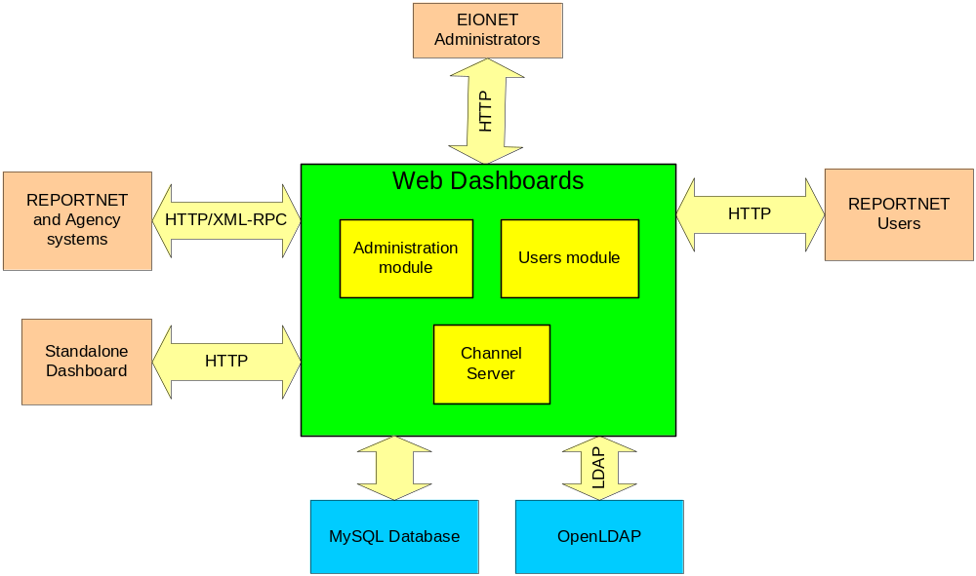

Figure 1 - Web Dashboards Service block diagram

Note: It should be noted that standalone dashboards will have same functions as EEA’s WDS. EEA’s WDS will provide for download this Standalone dashboard application.

Operating environment

- The WDS database management system shall be MySQL 4.1
- The WDS shall use the latest version of the web application server Apache Tomcat from 5.0.x branch
- The WDS shall operate under Linux OS Red Hat Enterprise 4.0
- The WDS shall use the EEA Open LDAP Server 2.0.27
- The WDS shall use the Java 2 SDK 1.4.2

Note: It should be noted that Open LDAP Server 2.0.27 does not seem to be compatible with Linux OS Red Hat Enterprise 4.0. The Contractor has installed the Open LDAP Server 2.0.27 on a different machine running under Linux OS Red Hat Enterprise 3.

Product Features
There are essentially four main functional areas of the REPORTNET Web Dashboards service.
The purpose of this section is to define and give an overview of the Use Cases that fall into three groups representing the functional areas of the REPORTNET Data Conversion Module. These are:
- System features;
- Administrative features;
- User features
The analysis of the related Use Cases (brief description, stimulus/response sequence and related requirements) will be presented in section 3.2

Administrative features
The administrative features of the WDS will allow the EIONET Administrator to manage the WDS application. Moreover, these functions will be organized in groups according to the WDS area that will be affected. The functional requirements related to the UNS administrative features are described in section 3.2.1 of this document. The following figure illustrates the groups of the administrative features that will be accessed from the WDS user interface.

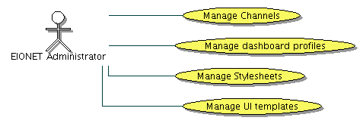
Figure 2 - Administrative features Use Case diagram

Administrative functions of the WDS comply with the following items:
- Management of the content channels
  - List PULL channels.
This feature will present list of the existing WDB content channels working in PULL mode. This function will be activated by default when an EIONET Administrator access to the channels management section of the WDB UI.
  - List PUSH channels.
This feature will present list of the existing WDB content channels working in PUSH mode.
  - Create content channel.
This function will allow the creation of the WDB content channels that will be used for pulling the external web services in RSS/RDF formed data.
  - Edit content channel.
This function will allow editing of the existing WDB content channels.
  - Remove content channel.
This function will allow removal of the existing WDB content channels.
  - Approve content channel
This function will allow an EIONET Administrators to enable or disable the usage of the PUSH channels created by external web services.
  - Define access rights.
This function is included in the Add content channel and Edit content channel features. It will allow an EIONET Administrators to define access privileges for a desired channel.
  - Define rendering mechanism
This function will allow the definition of the type of rendering mechanism that shall be used for specific channel. Two rendering mechanism will be available, Generic rendering and Rendering by XSL Transformation.

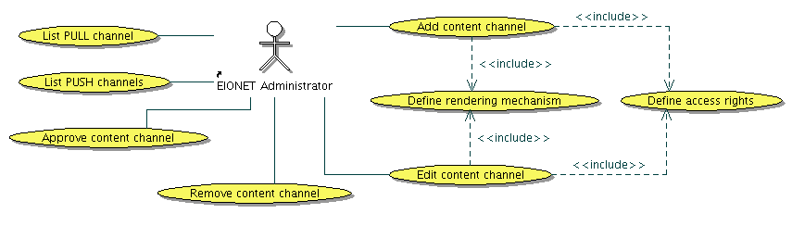
Figure 3 - Content channel management Use Case diagram

- Management of the dashboards profiles
  - Create dashboard profile
EIONET Administrators will be able to define dashboards profiles that users will be able to use as templates while defining their own dashboard profiles.
  - Remove dashboard profile
This function will allow removal of the existing dashboard profile
  - Edit dashboard profile
This function will allow editing of the existing dashboard profile

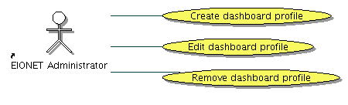
Figure 4 - Dashboard profiles management Use Case diagram

- Management of the Stylesheets intended to be used for rendering of the channels content at User interface.
  - Add stylesheet
This function will allow the creation of the new stylesheets
  - Edit stylesheet
This function will allow the editing of the existing stylesheets
  - Remove stylesheet
This function will allow the removal of the existing stylesheets which are not used for rendering any WDB channel
  - Test stylesheet
This function provide the possibility to the EIONET Administrators to run new or updated stylesheets against some existing channels or against some URI in order to check the correctness of the transformation.
  - Download stylesheet
  - Upload stylesheet
Administrators will be able to upload stylesheet file while adding or editing stylesheets in case that they don’t want to perform editions at WDB UI or if they have already available stylesheets.
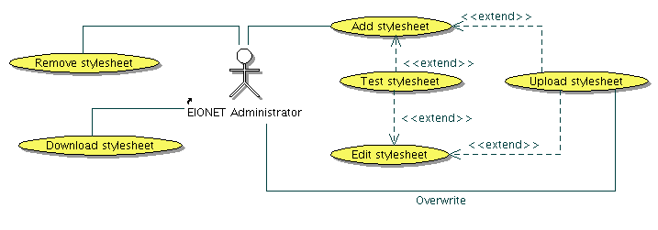
Figure 5 - Dashboard profiles management Use Case diagram

- Management of the defined parts of the User interface
By using this feature an EIONET Administrators will be able to perform some intervention on common User interface footer and header.
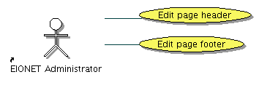
Figure 6 - Dashboard profiles management Use Case diagram

REPORTNET Users features
This set of functions will allow REPORTNET users to manage their dashboards profile information, download standalone dashboard application, view the desired dashboard and customize the layout of the channels presented on the dashboard.
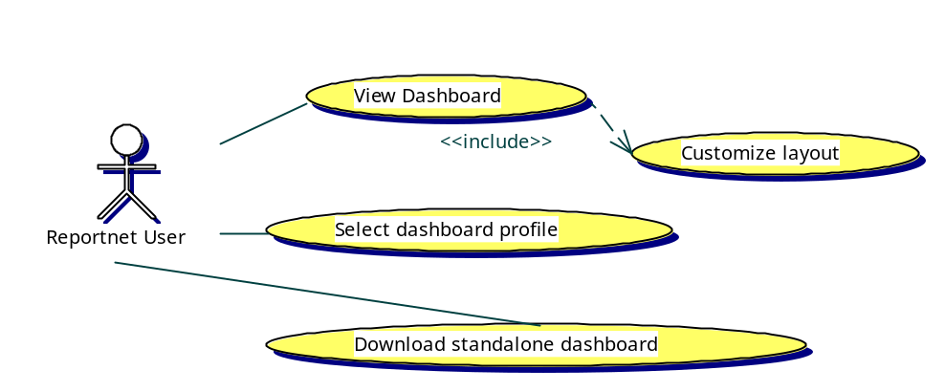

Figure 8 - REPORTNET User features Use Case diagram

Common features
These functions are common for all WDS users.
- Login. This feature will comprise the following functions:
  - Authentication
  - Authorization
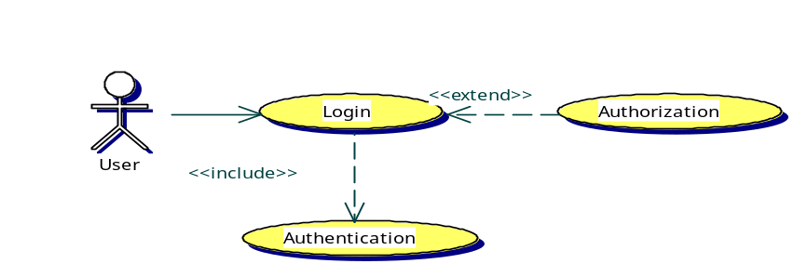
Figure 9 - Common features Use Case diagram

External system features
These functions will make the channel content available for use in other web services via XML syndication.
- Provide channel content. External EEAs Web services will be able toget channel content from the WDS by using this WDSs function. Moreover, standalone web dashboards will be able to access this function for the predefined list of channels.
- Get channel content. WDS will get data from the REPORTNET and from the other Agency web applications for each content channel. This function will be triggered during providing channel content to the EEAs Web services or during viewing of dashboards. Formats for channel feeds are RSS and RDF. The channel server will cache the harvested data as well as rendered data in order to improve server performance. Every PULL channel would have a time-to-live interval after which the content in cache will be updated.
- Render with XSL.
This function will allow rendering of the channel content for presentation purposes by using already defined stylesheets. According to the channel preferences the Get channel feature may be extended with this function.
- Render as generic.
This function will perfrom generic rendering of the RSS or RDF formed data. According to the channel preferences the Get channel feature may be extended with this function.The WDS can use only one of two posibble rendering mechanisms at the same time.
- Authenticate
External web services that want to communicate with the WDS through XML-RPC will have to authenticate themselves to the WDB before calling the desired operation.
- Create push channel
External web services will be able to create their channels at Web dashboards service which will wait for approval by an EIONET Administrator.
- Receive data (Apper as push to the external web service)
This WDS feature will allow authenticated external web service to push RDF formed data to the WDS.
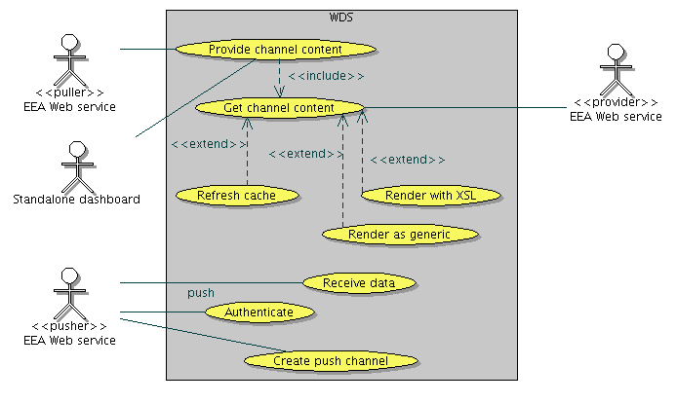

Figure 10 - External system features Use Case diagram

User Classes and Characteristics
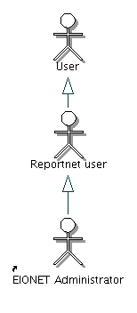
Figure 11 - User classes’ hierarchy Use case diagram

EIONET Administrator
An EIONET Administrator is an EEA employed responsible for the administration of the WDS.
This user needs to know all the functional aspects of the WDS, as well as some technical characteristics and terminologies. He/she will be a privileged user to execute all the administrative functions of the WDS. The system features which will perform administrative operations will only be authorized to this User class. In summarizing, EIONET Administrators responsibilities will be the management of dashboards profiles and the management of channels.

REPORTNET user
A REPORTNET User is an EEA LDAP server registered user who is allowed to select a desired type of dashboard profile and view the content of it. This user needs to have a clear understanding of the features offered by the WDS.

User
A User represents any user that may access the WDS web application.

User Documentation
The Web Dashboards Service shall provide an online hierarchical and cross-linked help system in HTML that describes and illustrates all system functions. The Web Dashboards Service shall provide a complete user manual for end users and EIONET administrators. The delivery format shall be MS Word.

Specific requirements
This section contains all of the WDS requirements at a level of detail sufficient to enable a system and system test case design which satisfies these requirements.

External Interface Requirements

User Interfaces
ID | REQ-3.1.1-1
Description | The WDS web client shall run on Microsoft Internet Explorer 5.5 and higher, Netscape Communicator 6.0 and higher and Opera 7.0 and higher.
Priority | High
Comments

ID | REQ-3.1.1-2
Description | The WDS UI should be full screen automatically for screen sizes of 800x600 pixels and up
Priority | High
Comments

ID | REQ-3.1.1-3
Description | The WDS user interfaces should be designed in accordance with good web design principles and the latest version of the EIONET design guidelines  (http://www.eionet.eu.int/software/).
Priority | High
Comments | EEA Design guidelines are covering all design aspects of WDS UI that this section of FSD document should describe.

Hardware Interfaces
No hardware interfaces have been identified.

Software Interfaces

ID | REQ-3.1.3-1
Description | The WDS shall expose channel data as RSS to other web services.
Priority | High
Comments

ID | REQ-3.1.3-2
Description | The WDS shall be able to get channel data from other web services via XML, RDF/RSS and XML RPC.
Priority | High
Comments

ID | REQ-3.1.3-3
Description | The WDS shall be able to communicate with the EEA LDAP server during the checking of user credentials.
Priority | High
Comments

Communications Interfaces

ID | REQ-3.1.4-1
Description | Other Web services shall be able to get XML data from the WDS by using the HTTP protocol.
Priority | High
Comments

Functional requirements
Functional requirements define the fundamental actions that must take place in the Web dashboard Service in accepting and processing the inputs and in processing and generating the outputs. These fundamentals actions will include the following items:
- a brief introduction,
- a stimulus and response sequence,
- the associated requirements.
The set of these items represents the essential information to outline a specific Use Case as presented in section 2.

EIONET Administrator

Manage the channel server

Introduction/Purpose
An EIONET Administrator whose identity has been verified shall have the option to manage the WDS channels.

Stimulus/Response sequence
Stimulus: Administrator requests to manage WDS channels
Response: WDS displays the list of already created channels and the list of channel management operations

Associated Functional requirements
ID | REQ-3.2.1.1.3-1
Description | The WDS shall let an EIONET Administrator who is logged into the system to manage the channels.
Priority | High
Comments

ID | REQ-3.2.1.1.3-2
Description | The WDS shall display the existing channels list and allow an EIONET Administrator to choose the desired operation. The following operations will be available:  - edit an existing channel  - delete an existing channel  - add a new channel  - manage access permissions
Priority | High
Comments

Add content channel

Introduction/Purpose
An EIONET Administrator whose identity has been verified shall have the option to add a new content channel.

Stimulus/Response sequence
Stimulus: Administrator requests to add a new content channel
Response: WDS queries Administrator for channel details
Stimulus: Administrator requests to submit new channel details
Response: WDS creates a new content channel and reports about the operation result

Associated Functional requirements
ID | REQ-3.2.1.2.3-1
Description | The WDS shall let an EIONET Administrator who is logged into the system to add a new content channel.
Priority | High
Comments

ID | REQ-3.2.1.2.3-2
Description | The WDS shall prompt the EIONET Administrator for the following channel details:  - name  - description  - channel type (RDF/RSS/XML RPC)  - content provider URL  - XML-RPC method (in case of XML-RPC channel type)  - Cache refresh interval (in seconds)
Priority | High
Comments

ID | REQ-3.2.1.2.3-3
Description | WDS shall test the connection to the external resource and prompt the EIONET Administrator in case of error before saving the configuration
Priority | High
Comments | WDS will test if the URL provided is correct. In case of XML-RPC WDS will try to execute the method provided.

ID | REQ-3.2.1.2.3-4
Description | WDS shall prompt the EIONET Administrator for the URL or local location of the XML Structure describing the semantics of the new channel
Priority | High
Comments | The objective is to use the XML description format for the channel data structure and its classification, mainly beneficial for the XML-RPC providers. Such an approach is also beneficial for the system to satisfy extensibility.

ID | REQ-3.2.1.2.3-5
Description | The WDS shall inform an EIONET Administrator about the success or failure of the operation with an appropriate message.
Priority | High
Comments

Edit content channel

Introduction/Purpose
An EIONET Administrator whose identity has been verified shall have the option to edit an existing content channel.

Stimulus/Response sequence
Stimulus: Administrator requests to edit a content channel
Response: WDS queries Administrator to select a desired channel
Stimulus: EIONET Administrator selects the desired channel and submits the request
Response: WDS shows the Administrator the existing parameters of the selected channel.
Stimulus: EIONET Administrator submits changes
Response: WDS reports about the operation result

Associated Functional requirements
ID | REQ-3.2.1.3.3-1
Description | The WDS shall let an EIONET Administrator who is logged into the system to edit a selected content channel.
Priority | High
Comments

ID | REQ-3.2.1.3.3-2
Description | The WDS shall allow the EIONET Administrator to edit the following details:  - name  - description  - channel type (RDF/RSS/XML RPC)  - content provider URL  - XML-RPC method (in case of XML-RPC channel type)  - Cache refresh interval (in seconds)
Priority | High
Comments

ID | REQ-3.2.1.3.3-3
Description | WDS shall test the connection to the external resource and prompt the EIONET Administrator in case of error before saving the configuration
Priority | High
Comments | WDS will test if the URL provided is correct. In case of XML-RPC it will try to execute the method provided.

ID | REQ-3.2.1.3.3-4
Description | The WDS shall inform an EIONET Administrator about the success or failure of the operation with an appropriate message.
Priority | High
Comments

Delete content channel

Introduction/Purpose
An EIONET Administrator whose identity has been verified shall have the option to delete a content channel.

Stimulus/Response sequence
Stimulus: Administrator requests to delete a selected content channel
Response: WDS queries Administrator for confirmation of channel delete
Stimulus: Administrator confirms to delete the channel
Response: WDS deletes the content channel

Associated Functional requirements
ID | REQ-3.2.1.4.3-1
Description | The WDS shall let an EIONET Administrator who is logged into the system to delete a selected content channel.
Priority | High
Comments

ID | REQ-3.2.1.4.3-2
Description | The WDS shall prompt an EIONET Administrator for confirmation of channel deletion.
Priority | High
Comments

ID | REQ-3.2.1.4.3-3
Description | The WDS shall inform an EIONET Administrator about the success or failure of the operation with an appropriate message.
Priority | High
Comments

Manage Access permissions

Introduction/Purpose
An EIONET Administrator whose identity has been verified shall have the option to connect an existing content channel to an existing user group.

Stimulus/Response sequence
Stimulus: Administrator requests to assign a content channel to a users group.
Response: WDS displays the list of existing channels and the list of user roles
Stimulus: Administrator selects channels and user groups and submits the request
Response: WDS reports about the operation result

Associated Functional requirements
ID | REQ-3.2.1.5.3-1
Description | The WDS shall let an EIONET Administrator who is logged into the system to assign one or more content channels to desired user groups.
Priority | High
Comments

ID | REQ-3.2.1.5.3-2
Description | The WDS shall inform an EIONET Administrator about the success or failure of the operation with an appropriate message.
Priority | High
Comments

Manage dashboard profiles

3.2.1.6.1 Introduction/Purpose
An EIONET Administrator whose identity has been verified shall have the option to manage the dashboard profiles.

Stimulus/Response sequence
Stimulus: Administrator requests to manage dashboard profiles
Response: WDS displays the list of existing dashboards
Stimulus: Administrator requests to add a new dashboard profile, change or delete a selected dashboard profile

Associated Functional requirements
ID | REQ-3.2.1.6.3-1
Description | The WDS shall let an EIONET Administrator who is logged into the system to manage dashboard profiles.
Priority | High
Comments

ID | REQ-3.2.1.6.3-2
Description | The WDS shall display the dashboard list and allow the EIONET Administrator to choose out of the following operations:  - edit an existing dashboard profile  - delete a selected dashboard profile  - Add a new dashboard profile.
Priority | High
Comments

Create dashboard profile

Introduction/Purpose
An EIONET Administrator whose identity has been verified shall have the option to create new dashboard profile that will provide channels to the REPORTNET users.

Stimulus/Response sequence
Stimulus: Administrator requests to create a new dashboard profile
Response: WDS queries Administrator for dashboard profile details
Stimulus: Administrator requests to submit new dashboard profile details
Response: WDS creates a new dashboard profile and reports about the operation result.

Associated Functional requirements
ID | REQ-3.2.1.7.3-1
Description | The WDS shall let an EIONET Administrator who is logged into the system to create a new dashboard profile.
Priority | High
Comments

ID | REQ-3.2.1.7.3-2
Description | The WDS shall prompt the EIONET Administrator for the following details:  - Name of the new dashboard profile  - Description for the new dashboard profile  - List of channels that the new dashboard profile shall present to the REPORTNET users (selection to be allowed from the list of existing channels).
Priority | High
Comments

ID | REQ-3.2.1.7.3-3
Description | The WDS shall inform an EIONET Administrator about the success or failure of the operation with an appropriate message.
Priority | High
Comments

Edit dashboard profile

Introduction/Purpose
An EIONET Administrator whose identity has been verified shall have the option to edit an existing dashboard profile.

Stimulus/Response sequence
Stimulus: Administrator requests to edit a dashboard profile
Response: WDS queries Administrator for dashboard profile details
Stimulus: Administrator requests to submit new dashboard profile details
Response: WDS updates the dashboard profile

Associated Functional requirements
ID | REQ-3.2.1.8.3-1
Description | The WDS shall let an EIONET Administrator who is logged into the system to edit a dashboard profile.
Priority | High
Comments

ID | REQ-3.2.1.8.3-2
Description | The WDS shall allow an EIONET Administrator to edit the following details:  - Name of the existing dashboard profile  - Description for the existing dashboard profile  - List of channels that the existing dashboard profile shall present to the REPORTNET users (selection to be allowed from the list of existing channels. De-selection to be allowed from the list of already assigned channels to the existing dashboard profile)
Priority | High
Comments

ID | REQ-3.2.1.8.3-3
Description | The WDS shall inform an EIONET Administrator about the success or failure of the operation with an appropriate message.
Priority | High
Comments

Delete dashboard profile

Introduction/Purpose
An EIONET Administrator whose identity has been verified shall have the option to delete an existing dashboard profile.

Stimulus/Response sequence
Stimulus: Administrator requests to delete a selected dashboard profile
Response: WDS queries Administrator for confirmation of dashboard profile deletion
Stimulus: Administrator confirms to delete the dashboard profile
Response: WDS deletes the dashboard profile

Associated Functional requirements
ID | REQ-3.2.1.9.3-1
Description | The WDS shall let an EIONET Administrator who is logged into the system to delete an existing dashboard profile.
Priority | High
Comments

ID | REQ-3.2.1.9.3-2
Description | The WDS shall prompt the EIONET Administrator for confirmation of dashboard profile deletion.
Priority | High
Comments

ID | REQ-3.2.1.9.3-3
Description | The WDS shall inform an EIONET Administrator about the success or failure of the operation with an appropriate message.
Priority | High
Comments

Manage UI templates

Introduction/Purpose
An EIONET Administrator whose identity has been verified shall have the option to access the UI management section of the Administrative UI and choose a desired operation.

Stimulus/Response sequence
Stimulus: The administrator requests access to the User Interface management section of the WDS.
Response: The WDS shows the Administrator the list of allowed operations.

Associated Functional requirements
ID | REQ-3.2.1.10.3-1
Description | The WDS shall let an EIONET Administrator who is logged into the system to access the content UI management section.
Priority | High
Comments

ID | REQ-3.2.1.10.3-2
Description | The WDS shall show the EIONET Administrator the menu of allowed UI operations:  - Edit page header  - Edit page footer
Priority | High
Comments

Edit page header

Introduction/Purpose
An EIONET Administrator whose identity has been verified shall have the option to edit a WDS web site page header

Stimulus/Response sequence
Stimulus: The administrator requests to edit a UI page header.
Response: The WDS shows the administrator the list of predefined UI elements and the general design items that can be changed
Stimulus: The administrator changes the template and submits the data
Response: The WDS saves the template and makes it visible

Associated Functional requirements
ID | REQ-3.2.1.11.3-1
Description | The WDS shall let an EIONET Administrator who is logged into the system to edit UI page header design elements.
Priority | High
Comments

ID | REQ-3.2.1.11.3-2
Description | The WDS shall allow editing the following UI elements:  - Hyperlinks  - Images  - Text
Priority | High
Comments | All elements will be placed in the predefined matrix.

ID | REQ-3.2.1.11.3-3
Description | The WDS shall allow editing of the following UI elements attributes:  - Position of elements (Inside of predefined matrix)
Priority | High
Comments

ID | REQ-3.2.1.11.3-4
Description | The WDS shall inform an EIONET Administrator about the success or failure of the operation with an appropriate message.
Priority | High
Comments

Edit page footer

Introduction/Purpose
An EIONET Administrator whose identity has been verified shall have the option to edit the WDS web site page footer.

Stimulus/Response sequence
Stimulus: The administrator requests to edit the UI page footer.
Response: The WDS shows the administrator the list of predefined UI elements and the general design items that can be changed
Stimulus: The administrator changes the template and submits the data
Response: The WDS saves the template and makes it visible

Associated Functional requirements
ID | REQ-3.2.1.12.3-1
Description | The WDS shall let an EIONET Administrator who is logged into the system to edit UI page footer design elements.
Priority | High
Comments

ID | REQ-3.2.1.12.3-2
Description | The WDS shall allow editing the following UI elements:  - Hyperlinks  - Images  - Text
Priority | High
Comments | All elements will be placed in the predefined matrix.

ID | REQ-3.2.1.12.3-3
Description | The WDS shall allow editing of the following UI elements attributes:  - Position of elements (Inside of predefined matrix)
Priority | High
Comments

ID | REQ-3.2.1.12.3-4
Description | The WDS shall inform an EIONET Administrator about the success or failure of the operation with an appropriate message.
Priority | High
Comments

Manage stylesheets

Introduction/Purpose
An EIONET Administrator whose identity has been verified shall have the option to manage the WDS stylesheets which will be used for channel content rendering at WDS User interface

Stimulus/Response sequence
Stimulus: Administrator requests to manage WDS stylesheets
Response: WDS displays the list of the existing stylesheets and the list of stylesheet management operations

Associated Functional requirements
ID | REQ-3.2.1.13.3-1
Description | The WDS shall let an EIONET Administrator who is logged into the system to manage the stylesheets.
Priority | High
Comments

ID | REQ-3.2.1.13.3-2
Description | The WDS shall display the existing channels list and allow an EIONET Administrator to choose the desired operation. The following operations will be available:  - edit an existing stylesheet  - delete an existing stylesheet  - add new stylesheet  - download an existing stylesheet  - test an existing stylesheet
Priority | High
Comments

Add stylesheet

Introduction/Purpose
An EIONET Administrator whose identity has been verified shall have the option to add a new stylesheet.

Stimulus/Response sequence
Stimulus: Administrator requests to add a new stylesheet
Response: WDS queries Administrator for stylesheet details
Stimulus: Administrator requests to submit new stylesheet details
Response: WDS validates provided stylesheet content, creates a new stylesheet and reports about the operation result

Associated Functional requirements
ID | REQ-3.2.1.2.3-1
Description | The WDS shall let an EIONET Administrator who is logged into the system to add a new stylesheet.
Priority | High
Comments

ID | REQ-3.2.1.14.3-2
Description | The WDS shall prompt the EIONET Administrator for the following stylesheet details:  - name  - description  - stylesheet content  - location to the stylesheet content ( as alternative )
Priority | High
Comments

ID | REQ-3.2.1.14.3-3
Description | WDS shall validate XSL and prompt the EIONET Administrator in case of an error before saving the data
Priority | High
Comments

ID | REQ-3.2.1.14.3-5
Description | The WDS shall inform an EIONET Administrator about the success or failure of the crate operation with an appropriate message.
Priority | High
Comments

Edit stylesheet

Introduction/Purpose
An EIONET Administrator whose identity has been verified shall have the option to edit an existing stylesheet.

Stimulus/Response sequence
Stimulus: Administrator requests to edit a stylesheet
Response: WDS shows the Administrator the existing data of the selected stylesheet.
Stimulus: EIONET Administrator submits changes
Response: WDS reports about the operation result

Associated Functional requirements
ID | REQ-3.2.1.15.3-1
Description | The WDS shall let an EIONET Administrator who is logged into the system to edit a desired stylesheet
Priority | High
Comments

ID | REQ-3.2.1.15.3-2
Description | The WDS shall allow the EIONET Administrator to edit the following details:  - name  - description  - stylesheet content  - location to the new stylesheet content ( as alternative )
Priority | High
Comments

ID | REQ-3.2.1.15.3-3
Description | WDS shall validate XSL and prompt the EIONET Administrator in case of an error before saving the data
Priority | High
Comments | WDS will test if the URL provided is correct. In case of XML-RPC it will try to execute the method provided.

ID | REQ-3.2.1.15.3-4
Description | The WDS shall inform an EIONET Administrator about the success or failure of the operation with an appropriate message.
Priority | High
Comments

Remove stylesheet

Introduction/Purpose
An EIONET Administrator whose identity has been verified shall have the option to remove a existing stylesheet

Stimulus/Response sequence
Stimulus: Administrator requests to delete a selected stylesheet
Response: WDS queries Administrator for confirmation of stylesheet delete
Stimulus: Administrator confirms to delete the stylesheet
Response: WDS deletes the stylesheet

Associated Functional requirements
ID | REQ-3.2.1.16.3-1
Description | The WDS shall let an EIONET Administrator who is logged into the system to delete a selected stylesheet
Priority | High
Comments

ID | REQ-3.2.1.16.3-1
Description | The WDS shall not allow removal of stylesheets which are used by some of existing content channels
Priority | High
Comments

ID | REQ-3.2.1.16.3-2
Description | The WDS shall prompt an EIONET Administrator for confirmation of stylesheet deletion.
Priority | High
Comments

ID | REQ-3.2.1.16.3-3
Description | The WDS shall inform an EIONET Administrator about the success or failure of the stylesheet deletion with an appropriate message.
Priority | High
Comments

Test stylesheet

Introduction/Purpose
An EIONET Administrator whose identity has been verified shall have the option to add a new stylesheet.

Stimulus/Response sequence
Stimulus: Administrator requests to test a stylesheet
Response: WDS queries Administrator to select channel for testing or to provide URL of the XML formed data to be used for test.
Stimulus: Administrator requests to execute test
Response: WDS apply transformation scenario and returns transformation output.

Associated Functional requirements
ID | REQ-3.2.1.17.3-1
Description | The WDS shall let an EIONET Administrator who is logged into the system to test a stylesheet.
Priority | High
Comments | Test will be reachable for new stylesheets as well as for existing.

ID | REQ-3.2.1.17.3-2
Description | The WDS shall prompt the EIONET Administrator for the following test scenario details:  - To pick up the desired channel for testing (from the list of the existing content channels)  - URL of the XML formed data (as alternative )
Priority | High
Comments

ID | REQ-3.2.1.17.3-3
Description | WDS shall present to the EIONET Administrator result of the applied transformation scenario. In case of system errors the WDS shall prompt appropriate message
Priority | High
Comments

REPORTNET user

Select dashboard profile

Introduction/Purpose
A REPORTNET user whose identity has been verified shall have the option to select a desired dashboard profile.

Stimulus/Response sequence
Stimulus: REPORTNET User requests to change a dashboard profile
Response: WDS queries user to choose a dashboard profile from the list of available dashboard profiles
Stimulus: User selects the desired dashboard and submits the request.
Response: WDS saves the configuration for the authenticated user and reports the operation result.

Associated Functional requirements
ID | REQ-3.2.2.1.3-1
Description | The WDS shall let a REPORTNET User who is logged into the system to choose a desired dashboard profile from the list of available dashboard profiles
Priority | High
Comments

ID | REQ-3.2.2.1.3-2
Description | A REPORTNET User shall be able to see the channels assigned to a dashboard by selecting a dashboard from the list.
Priority | High
Comments

View dashboard

Introduction/Purpose
A REPORTNET user shall have the option to view the dashboard he/she subscribed to.

Stimulus/Response sequence
Stimulus: REPORTNET User accesses the WDS web site.
Response: WDS tries to read the cookie located on User’s workstation and presents the User the cookie dashboard identified. If the cookie does not exist WDS redirects the user to the login dialog.
Stimulus: REPORTNET User logs in into WDS.
Response: WDS presents the user the dashboard related to his/her profile.

Associated Functional requirements
ID | REQ-3.2.2.2.3-1
Description | The WDS shall let a REPORTNET User who has saved a cookie related to his/her profile to view a selected dashboard.
Priority | High
Comments

ID | REQ-3.2.2.2.3-2
Description | The WDS shall prompt a REPORTNET User to login into the system in case the cookie does not exist.
Priority | High
Comments

ID | REQ-3.2.2.2.3-3
Description | The WDS shall allow a REPORTNET User to see channels assigned to his/her user group.
Priority | High
Comments | If some of channels that dashboard contains are not assigned to a user group where an REPORTNET User belong, those channels will not be visible on dashboard.

ID | REQ-3.2.2.2.3-4
Description | If presented channel content contains hyperlinks, the WDS shall open it in new popup window in case that a REPORTNET User wants to access the provided URL.
Priority | High
Comments

Customize layout

Introduction/Purpose
A REPORTNET user shall have the option to customize the layout of channels that the dashboard related to his/her profile contains.

Stimulus/Response sequence
Stimulus: REPORTNET User requests to move some of the channel portlet windows
his/her dashboard contains.
Response: WDS performs the change, stores the new layout information and presents the user the changed layout.

Associated Functional requirements
ID | REQ-3.2.2.3.3-2
Description | A REPORTNET User shall be able to perform the following operations on the channel portlet window:  - move left  - move right  - move up  - move down
Priority | High
Comments

Download standalone dashboard

Introduction/Purpose
A REPORTNET user shall have the option to download the standalone dashboard application from the EEA’s WDS.

Stimulus/Response sequence
Stimulus: REPORTNET User requests to download the standalone dashboard application.
Response: WDS prompt user to confirm download of application archive.

Associated Functional requirements
ID | REQ-3.2.2.4.3-1
Description | The WDS shall let a REPORTNET User to download Standalone dashboard application.
Priority | High
Comments

Common features

Login

Introduction/Purpose
A User who wants access to WDS protected functions needs to login into the system.

Stimulus/Response sequence
Stimulus: REPORTNET User requests to login on the WDS.
Response: WDS queries User to enter a username and a password

Associated Functional requirements
ID | REQ-3.2.3.1.3-1
Description | The WDS shall allow a registered User to login.
Priority | High
Comments

ID | REQ-3.2.3.1.3-2
Description | In case of WDSuccessful login the WDS shall keep a login dialog resembling to an error message that will inform the user about the inappropriate data provided.
Priority | High
Comments

ID | REQ-3.2.3.1.3-3
Description | In case of successful login the WDS shall perform authorization and will show the user all features of the WDS User Interface allowed to his/her role.
Priority | High
Comments

External system features

Provide channel content

Introduction/Purpose
External EEA Web services shall have the option to access the WDS and get content available from the existing channels.

Stimulus/Response sequence
Stimulus: External EEA Web Service request data for the specified channel.
Response: WDS return channel data to the External EEA Web Service.

Associated Functional requirements
ID | REQ-3.2.4.1.3-1
Description | The WDS shall make the channel content available for use to other web services.
Priority | High
Comments

Get channel content

Introduction/Purpose
The WDS content channel server shall be able to get content from external EEA Web services by using created content channels.

Stimulus/Response sequence
Stimulus: View dashboard function is triggered by the REPORTNET User OR Provide channel content is triggered by the EEA Web service.
Response: WDS checks cache state for the specified channel. If cache content exists and refresh time interval has not expired it provide cache data to the caller. If cache content does not exists or refresh time interval has expired queries external systems for channel data, saves data in the cache and gives it back to the caller.

Associated Functional requirements
ID | REQ-3.2.4.2.3-1
Description | The WDS shall be able to get content for the created channels from the external EEA Web services.
Priority | High
Comments

ID | REQ-3.2.4.2.3-2
Description | The WDS shall cache fetched data from the External EEA Web service in order to improve server performance.
Priority | High
Comments

ID | REQ-3.2.4.2.3-3
Description | The WDS shall not fetch data from the External EEA Web service if cache for specified channel is not empty and refresh time interval has not expired.
Priority | High
Comments

ID | REQ-3.2.4.2.3-4
Description | The WDS shall render fetched data from the External EEA Web service and store the data inside its cache
Priority | High
Comments

ID | REQ-3.2.4.2.3-5
Description | According to the channel preferences the WDS shall render fetched data by using XSLT or Generic renderer.
Priority | High
Comments

ID | REQ-3.2.4.2.3-6
Description | The WDS shall trigger this function always when content is required. The following list presents the functions that require getting of channels content:  - View dashboard  - Provide channel content
Priority | High
Comments

ID | REQ-3.2.4.2.3-7
Description | In case of errors the WDS shall return a defined error code.
Priority | High
Comments | The list of error codes will be defined during the system design phase.

Authenticate external application

Introduction/Purpose
An External web service that requests access to the WDS XML-RPC features will need to authenticate.

Stimulus/Response sequence
Stimulus: External web service requests to authenticate itself in the WDS.
Response: WDS returns authentication results to the external web service

Associated Functional requirements
ID | REQ-3.2.4.3.3-1
Description | The WDS shall allow an External web service to authenticate itself.
Priority | High
Comments

ID | REQ-3.2.4.3.3-1
Description | The WDS shall request login information for each External web service separately.
Priority | High
Comments | Each External Web service needs to have its own credentials for authentication purposes. This will allow WDS to track activities of External Web services as well as to prevent pushing of data to channels that are not directly created by the service that makes the call.

ID | REQ-3.2.4.3.3-2
Description | In case of unsuccessful authentication WDS shall return HTTP 401 error code 200, otherwise an OK message shall be returned.
Priority | High
Comments

Create push channel

Introduction/Purpose
An External web service whose identity has been verified shall have the option to create a new content channel.

Stimulus/Response sequence
Stimulus: External web service requests to create a new content channel
Response: WDS creates a new content channel, reports External web service about the operation result and returns channel identifier that may be used later for pushing of data.

Associated Functional requirements
ID | REQ-3.2.4.4.3-1
Description | The WDS shall let an External web service who is logged into the system to create a new content channel.
Priority | High
Comments

ID | REQ-3.2.4.4.3-2
Description | The WDS shall expect from the External web service the following channel details:  - name  - description
Priority | High
Comments

ID | REQ-3.2.4.4.3-3
Description | WDS shall not allow pushing of data by the new channel until an EIONET Administrator approves it.
Priority | High
Comments | WDS will test if the URL provided is correct. In case of XML-RPC WDS will try to execute the method provided.

ID | REQ-3.2.4.4.3-5
Description | The WDS shall return to the External web service identifier of the new created channel
Priority | High
Comments

Receive events data

Introduction/Purpose
An External web service whose identity has been verified shall have the option to push a data by using its channel which has been approved by an EIONET Administrator.

Stimulus/Response sequence
Stimulus: An external web service pushes data to the WDS
Response: The WDS receives the data and returns operation result.

Associated Functional requirements
ID | REQ-3.2.4.5.3-1
Description | The WDS shall be able to receive events data from the External Web services or other REPORTNET modules.
Priority | High
Comments

ID | REQ-3.2.4.5.3-2
Description | The WDS shall not allow External web service to push data before an EIONAT Administrator approve channel created by same service.
Priority | High
Comments

ID | REQ-3.2.4.2.5-3
Description | The WDS shall check the received data.
Priority | High
Comments

ID | REQ-3.2.4.5.3-4
Description | The WDS shall merge the existing channel data with received one.
Priority | High
Comments | This refers to the WDS capability to make a distinction between new data and already received data in order to avoid duplicate entries for the specific PUSH channel in the WDS database.

ID | REQ-3.2.4.5.3-5
Description | In case of errors the WDS shall record the error details into the system log in order to allow EIONET administrators tracking of receiving processes.
Priority | High
Comments

Nonfunctional requirements
The Web Dashboards Service cannot only be specified by concrete functional requirements; the so-called non-functional requirements gain in importance especially with respect to the software quality.
Non-functional requirements are requirements which are not specifically concerned with the functionality of a software system. Instead, non-functional requirements place restrictions on the product being developed and the development process, and they specify external constraints that the product must meet.
Many non-functional requirements relate to the system as a whole rather than to individual system features. This means that they are often more critical than individual functional requirements. While failure to meet an individual functional requirement may degrade the system, failure to meet a non-functional system requirement may make the whole system unusable.

Software Quality Attributes

A software quality model, which is based on six main characteristics and their respective sub-characteristics, is outlined in the following figure:

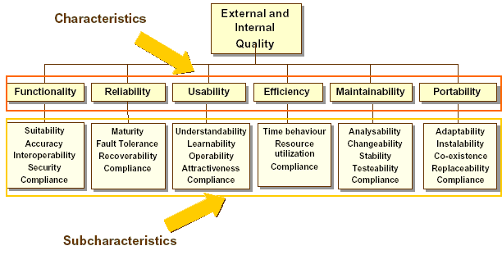

Figure 12 – Software quality attributes diagram

The detailed specification of the required software quality aspects for the Web Dashboards Service will be mainly based on this model.

Functionality
Functionality of the Web Dashboards Service is the capability to provide functions which meet stated and implied needs when the software is used under specified conditions. More specifically, the following aspects need to be taken into account:
- Suitability/Completeness. The capability of the WDS product to provide an appropriate set of functions for specified tasks and user objectives.
- Accuracy/Correctness. The capability of the WDS to provide the right or agreed results or effects with the needed degree of precision
- Interoperability. The capability of the WDS to interact with one or more specified systems.
- Security. The capability of the WDS product to protect information and data so that unauthorized persons or systems cannot read or modify this information and authorized persons or systems are not denied access to this information

ID | REQ-3.3.1.0-1
Description | The WDS shall be consistent with this functional specification.
Priority | High
Comments

ID | REQ-3.3.1.0-2
Description | The WDS should include a software integrity check and recovery
Priority | Medium
Comments | The Contractor may provide scripts that should be executed after installation of the WDS. This should generate MD5 sum file for each WDS file and save this in a special file that should be stored on a safe place.  The EIONET administrator should be able to execute the script periodically and compute MD5 sum for all files in application and check it against sum file for files integrity. If difference exists, then the script will generate warning indicating which file is corrupted.  The script may be installed as cron job also. So it may trigger integrity check periodically without need of manual script execution.

ID | REQ-3.3.1.0-3
Description | Access to the administration module of WDS shall be restricted only to EIONET administrators registered on the EEA LDAP.
Priority | High
Comments

Reliability

ID | REQ-3.3.1.1-1
Description | The WDS shall not corrupt or lose data.
Priority | High
Comments | This refers explicitly to the WDS system modules and their functions that will work with data. This excludes errors that may occur because of Operating system, Hardware, Network infrastructure, Database engine, Application server errors or any other software application or accidental human intervention that by interacting with the WDS system will result to corruption or loss of data.

ID | REQ-3.3.1.1-2
Description | The WDS should recognise violations of syntactic conditions for input. In case the WDS recognises an input as erroneous or as undefined, it shall not process this as a permissible input.
Priority | High
Comments | This corresponds to the capability of the WDS to avoid user mistakes while data are introduced through the UI. Therefore, it means that all input provided by the users shall be validated in order to proceed with the desired action as per the rules agreed by the Agency and the Contractor.

ID | REQ-3.3.1.1-3 <TBD>
Description | The WDS should have a 98% up-time
Priority | High
Comments | Availability: The percentage of time that the software system is fully functional.  The Contractor understands that the Agency is satisfied its current internal configuration of hardware, network infrastructure and the various monitoring and recovery mechanisms ensuring availability of services at the 98% level. It is understood that the Agency will undertake all necessary actions in terms of hardware, network infrastructure & monitoring and recovery mechanisms referring to all factors, apart from the software to be developed by the Contractor, that will allow a 98% up-time of the services discussed herein.

ID | REQ-3.3.1.1-4
Description | The WDS should work in a stable and responsive way with 30-50 concurrently logged in users accessing the system in accordance with the actions required by their user profile.
Priority | High
Comments | Appropriate Stress Tests will be developed and used to confirm that this has been achieved.

Usability

ID | REQ-3.3.1.2-1
Description | Ease of Overview. The WDS should provide information to the user in such a form that it is easily visible and easy to read. The user should be guided by appropriate coding and grouping of the information. Where necessary, the WDS should alert the user.
Priority | High
Comments | Effort will be made by the Contractor to meet this requirement. At the end of the evaluation and during the production support period the Contractor will spend an additional effort (up to the maximum allowed as defined in the PMQP document: 30 person days for a six months time period) to satisfy any comments that will be formally expressed by the Agency regarding this requirement.

ID | REQ-3.3.1.2-2
Description | Operability. The WDS shall give a clear warning of the consequences and request information before executing the command. In particular, erasure and overwriting of data, as well as interruptions of a lengthy processing operation, have serious consequences
Priority | High
Comments | Effort will be made by the Contractor to meet this requirement. At the end of the evaluation and during the production support period the Contractor will spend an additional effort (up to the maximum allowed as defined in the PMQP document: 30 person days for a six months time period) to satisfy any comments that will be formally expressed by the Agency regarding this requirement

Efficiency

ID | REQ-3.3.1.3-1
Description | The application should support around 2000 users
Priority | High
Comments | This refers to number of user that will have defined profiles in the WDS.

Maintainability

ID | REQ-3.3.1.4-1
Description | The WDS shall have a modular design to meet the functional features
Priority | High
Comments

ID | REQ-3.3.1.4-2
Description | Naming conventions should be applied to the development environment and the source code (e.g. expressive names for names for functions comprising prefixes from which the context can be derived).
Priority | High
Comments | Mainly the java naming conventions will be respected.  http://java.sun.com/docs/codeconv/html/CodeConvTOC.doc.html

Portability

ID | REQ-3.3.1.5-1
Description | The WDS modules shall operate under any distribution/version of Linux where the Operating environment described in 2.1.3 can be installed and be fully functional.
Priority | High
Comments | WDS installation scripts will be developed and tested only for the operating environment described in 2.1.3.  At the end of the evaluation and during the production support period the Contractor will spend an additional effort (up to the maximum allowed as defined in the PMQP document: 30 person days for a six months time period) to satisfy any comments that will be formally expressed by the Agency regarding these issues.

Design and implementation constraints

ID | REQ-3.3.2-1
Description | The application shall be based on the latest stable versions (approved by W3C) of XML, XSL, RSS/RDF, XHTML and CSS
Priority | High
Comments

ID | REQ-3.3.2-2
Description | The application shall use the latest stable versions of the EEAs ACL API
Priority | High
Comments

Appendix A: Example dashboard
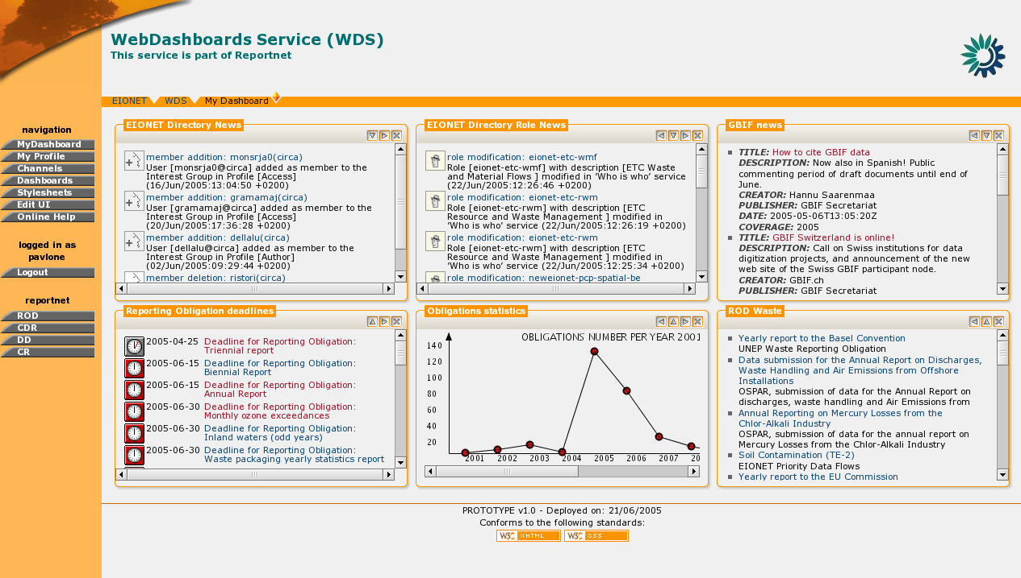
Figure 13 – Example dashboard layout

Appendix B: Requirements Traceability Matrix

Nr | CfT Requriement | Related FSD requirements
1 | The dashboard web service will be composed of a web front-end interface for users to view channels relevant to their profile. | REQ-3.2.2.2.3-1 - REQ-3.2.2.2.3-3
2 | A second user interface will allow users to set up and select their preferred dashboard type. | REQ-3.2.2.1.3-1 - REQ-3.2.2.1.3-2
3 | A web browser accessible administrative interface for the dashboard web service application will also be developed. Through the interface an administrator should be able to:  - Add, edit and remove content channels from the dashboard service;  - Administer the application and databases;  - Make modifications (add, edit or delete) content in the dashboard interface; as well as,  - Use the Agency's LDAP server and access permissions to define and administer a typology of dashboard profiles. | REQ-3.2.1.1.3-1 - REQ-3.2.1.1.3-2  REQ-3.2.1.2.3-1 - REQ-3.2.1.2.3-5  REQ-3.2.1.3.3-1 - REQ-3.2.1.3.3-4  REQ-3.2.1.4.3-1 - REQ-3.2.1.4.3-3  REQ-3.2.1.5.3-1 - REQ-3.2.1.5.3-2  REQ-3.2.1.6.3-1 - REQ-3.2.1.6.3-2  REQ-3.2.1.7.3-1 - REQ-3.2.1.7.3-3  REQ-3.2.1.8.3-1 - REQ-3.2.1.8.3-3  REQ-3.2.1.9.3-1 - REQ-3.2.1.9.3-3  REQ-3.2.1.10.3-1 - REQ-3.2.1.10.3-2  REQ-3.2.1.11.3-1 - REQ-3.2.1.11.3-4  REQ-3.2.1.12.3-1 - REQ-3.2.1.12.3-4
4 | The dashboard web service will principally harvest from the Content Registry application (http://cr.eionet.eu.int), but will also be able to harvest from other Agency databases and web applications | REQ-3.1.3-2
5 | The application should be based on the latest stable versions (approved by W3C) of XML, XSL, RSS/RDF, XHTML and CSS; | REQ-3.3.2-1
6 | The website should be full-screen automatically for screen size of 800x600 pixels and up | REQ-3.1.1-2
7 | The website should be compatible with IE 5.0, NS 6, Opera 7.0 and up | REQ-3.1.1-1
8 | The preferable environment is Linux | REQ-3.3.1.5-1
9 | The application layer should have a modular design to meet the functional features | REQ-3.3.1.4-1
10 | The application should include a software self-integrity check and recovery | REQ-3.3.1.0-2
11 | The application and website should have a 98% up- time (ie not more than 2% unplanned down-time) | REQ-3.3.1.1-3
12 | Password protection should allow administrative users to make changes to designated sections of the site | REQ-3.2.3.1.3-1 - REQ-3.2.3.1.3-3  REQ-3.2.1.10.3-1 - REQ-3.2.1.10.3-2  REQ-3.2.1.11.3-1 - REQ-3.2.1.11.3-4  REQ-3.2.1.12.3-1 - REQ-3.2.1.12.3-4
13 | The application should support around 2000 users | REQ-3.3.1.3-1
14 | The dashboard content server application will make the channel content available for use in other web services via XML syndication | REQ-3.1.3-1
15 | Develop six micro-sites based on channels provided from the dashboard channel content server | Separate development for the Standalone dashboard will not be needed since it will have same functions as EEAs one.

[END OF DOCUMENT]

Action: I = Insert; R = Replace; C = Creation

